***CyberArk Password Vault Log-On Instructions for accessing CDC.gov privileged account***

***Step 1*:** Access the CyberArk Password Vault (PVWA) by typing the below link into your *Microsoft Edge* browser:

[cyber.cdc.gov](https://pvwacl.cdc.gov/PasswordVault/logon.aspx?ReturnUrl=%2fPasswordVault%2f)

***Step 2:*** Sign into the CyberArk PVWA by using either your *CDC PIV* Smart Card or *Microsoft MFA* as explained below.

***NOTE: Once you first log into CyberArk, your managed privileged account will not be present. Please refer to Step 3 on how to make your privileged account visible.***

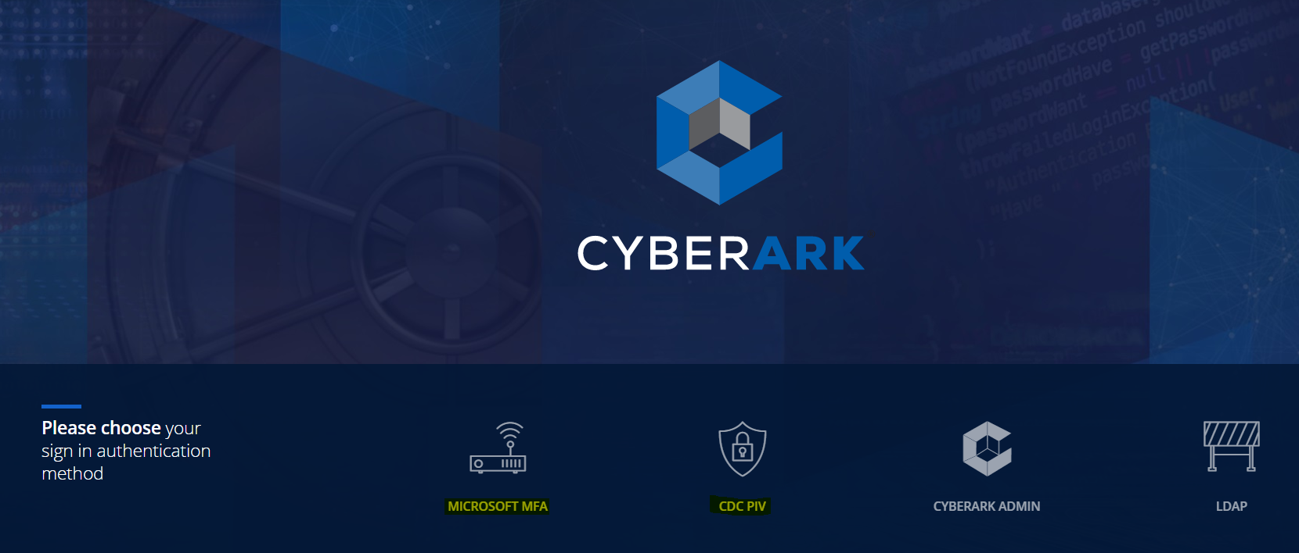

To sign into CyberArk using *Microsoft MFA*, click on the *Microsoft MFA* tile, then type in your primary user account ID and your network password, then click on *Sign in*.

***NOTE: Prior to utilizing the Microsoft MFA authentication option, please ensure that you have already successfully registered for Microsoft MFA in advance via the following URL to configure your secondary verification method(s):*** [***https://aka.ms/mfasetup***](https://aka.ms/mfasetup)

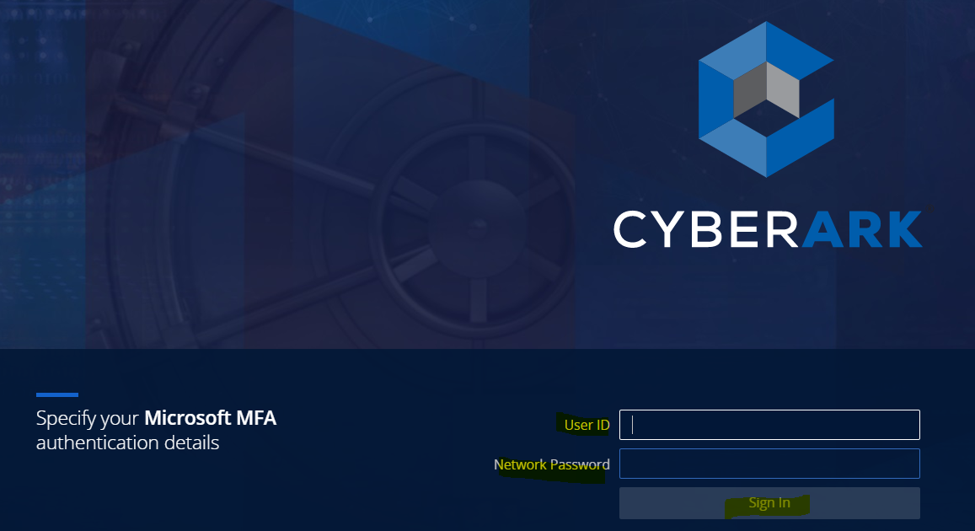

To sign into CyberArk PVWA using your primary user account and *CDC Smart Card* ***(smart card with your photo on it)***,click on *CDC PIV* tile and insert your Smart Card into the card reader, then select *CDC PIV*. Enter in your Smart Card PIN when prompted, then press *OK*.

Next, based on your preferred verification method selected, you will either need to verify your identity via phone call, approve your sign-in from within the *Microsoft Authenticator* app, or further authenticate by entering in a verification code generated within the *Microsoft Authenticator* app.

***Page 1 of 3***

***Step 3:*** Once signed into CyberArk, you will see the *Account view* page with no privileged account present. Next, up in the top left-hand corner of the *Account view* screen, click on the magnifying glass icon which is located next to the field labeled *Search for accounts.* This will bring up your privileged account that is now being managed by CyberArk.

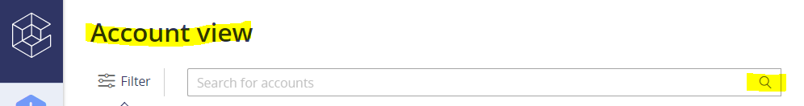

***Step 4:*** After you have located your privileged account, click anywhere on the discovered account.



On the right-side of the *Account view* page, you will see a new pane presented. From this view, you can click on *Show* to view your privileged account password and *Copy* to copy your privileged account password which will be used for authenticating in the *CDC.gov* domain.

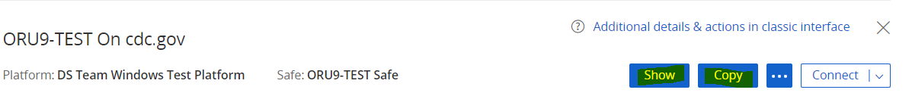

***The next 2 steps, Steps 5 and 6, are only applicable for privileged account users that will need to remotely connect to Windows CDC domain-joined target machines and/or Linux CDC domain-joined target machines. The RDP and SSH features are both accessible from the Account View page.***

***Step 5:*** To remotely connect to a Windows machine using ***RDP*** in CyberArk, click on the ***Connect*** button which is located right next to the *Copy* and ••• button. ***NOTE: By default, RDP will be the pre-selected connection option***.

You should then see the *Connect* window displayed. You are not required to type in any information into the *Reason* field as this is optional. Under *Remote Connection Details*, you will see a toggle switch for *Map local drives*. By default, the *Map local* *drives* will already be turned on. Under *Remote Machine*, type in the name of the machine into the field. You can also type in the Fully Qualified Domain Name *(e.g. machinename.cdc.gov)*. Next, press the *Connect* button to initiate the ***RDP*** session. You will then see the *Downloads* option presented in the upper-right hand corner of the

*MS Edge* browser page. Lastly, click on the *Open file* which will be displayed in the upper right-hand corner area of the browser page to initiate the ***RDP*** session.

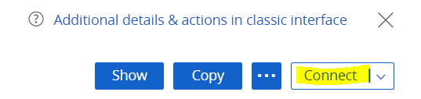

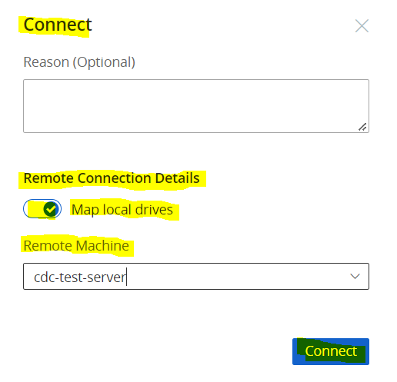

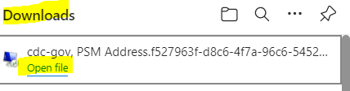

***Page 2 of 3***

***Step 6:*** To remotely connect to a Linux machine using ***SSH*** in CyberArk, click on the dropdown right next to the Connect button and select the ***SSH*** option by clicking on the dropdown arrow.

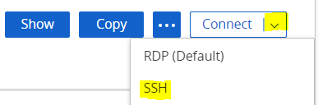

From the *Connect* window, type in either the machine name or IP address of the Linux machine into the *Enter Remote Machine* field displayed under the *Remote Connection Details* section. Next, press the *Connect* button and an

***SSH*** session will begin being established.

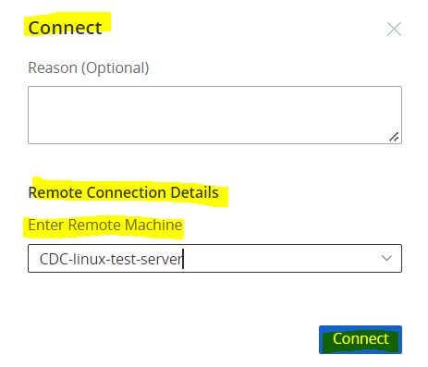

You will then see the *Downloads* option presented in the upper-right hand corner of the

*MS Edge* browser page. Click on *Open file* to start the ***SSH*** session.



***\*\*\* Any further questions/concerns, please feel free to email CyberArk Ask (CDC) for assistance. \*\*\****

***Page 3 of 3***